Eleanor Dillon-Reams
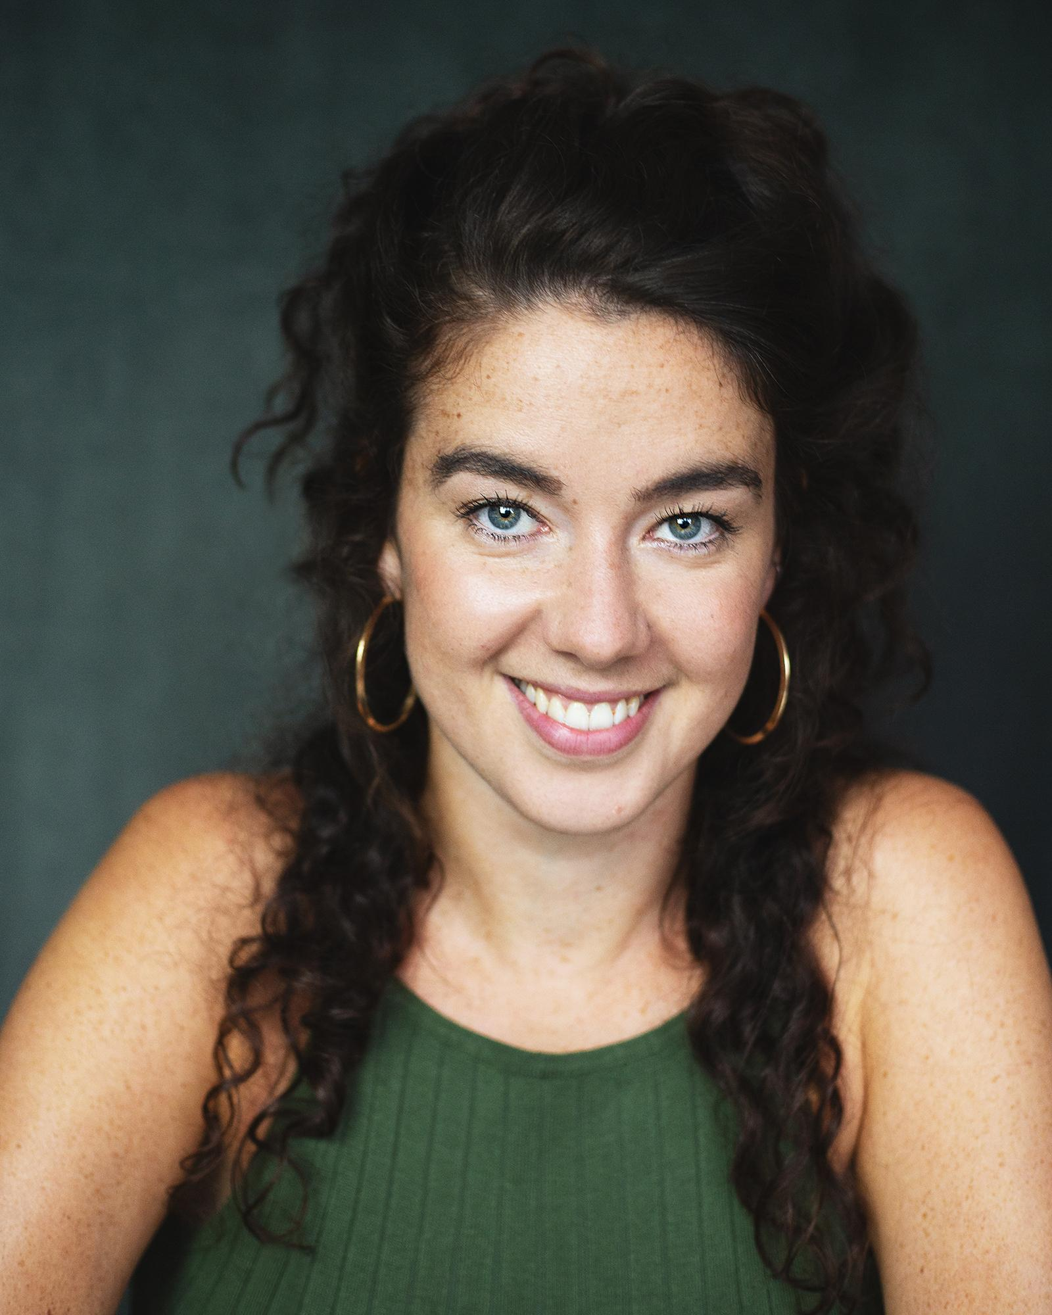
Telephone: 07770 906 498

Email: edillonreams@gmail.com

TRAINING:
First class BA Hons in Acting
East 15 Acting School
2009-2012

English Literature A Level (A)
Dance A Level (A)
Performing Arts Nat. Cert. (Distinction)
Sussex Downs College
2006-2008

11 GCSEs A*- B
Dorothy Stringer High School
2001-2006
Photo by: Rosie Kernohan
Full DBS
Public Liability Insurance
First Aider

Spotlight No. : 8464-0195-7197
Equity No. :00403913

DIRECTING:
#METOO a Brechtian Cabaret - East 15 Acting School BA2- May 2020
Lemons, Lemons, Lemons, Lemons, Lemons- YATI foundation- Jan- May 2020
Nothing in the World but Youth- FILM- Mountview FMT Jan- April 2020
A creative contribution to the BLM movement- YATI foundation Mar-July 2020
Dance Nation- Clare Barron- YATI Foundation- November 2019- Feb 2020
Community- Verbatim Project- Mountview Foundation- Jan-March 2019
To Skin a Cat- Isley Lynn- YATI Foundation Students- January-April 2019
Wasted- Kate Tempest : YATI Foundation Students – YATI- May 2018
As You Like It – Shakespeare - YATI foundation Students- YATI – January 2018
Charlie and the Chocolate Factory- Adapted by Richard George: YATI -August 2017
All My Sons- Arthur Miller- YATI Foundation Students – YATI- May 2017
The Changeling- Thomas Middleton- YATI Foundation Students – YATI- Dec 2016

ACTING TEACHING/ WORKSHOP FACILITATING:

Part of the East 15 Acting School Alumni Mentorship programme- one to one mentoring current and graduating students.

LAMDA Teacher Working on a one to one basis directing and tutoring students for upcoming LAMDA exams

Facilitator/ Director Working with a selected group of teenagers devising a
Mountview Theatre School new piece entitled ‘My Generation’
September 2018- present

Creative Writing/ Storytelling Tutor
Chiswick Short Courses Delivering specialist workshops to 8-14 year olds
August 2017- present

Workshop Leader/ Facilitator Working across the UK, as well as India, Singapore, The Handlebards Bali, Malaysia, Sudan delivering bespoke workshops September 2016- March 2018 to ages 8- adult, on Shakespearian text, Laban,
devising, and physical theatre

Drama Teacher/ Shakespeare Specialist Specialised working with 3-5 year olds
PQA (Pauline Quirke Accademy)
August 2016- present

Drama Teacher Working across the year groups to deliver drama
Cranbrook Primary School sessions based on the curriculum
January 2015- July 2016

Arts Specialist- Dance & Drama Working in Schools across the UK to boost
Artis achievement, improve speaking & listening skills and January 2014- present build confidence and self-esteem

Drama Teacher/Director With the 18- 25 year old foundation students:
YATI: Young Actors Theatre Islington Shakespeare, Spoken word, Laban, Chekhov,
September 2013- present modern text, Jacobean literature, movement,
American Literature, Audition technique,
acting through song, devising, writing, clowning

Drama teacher Under 8’s Performing Arts Classes
Cherrystars at The Brit School
December 2013- December 2017

Acting & Dance Coach
RAaW
September 2013- August 2014

English Tutor – One to one tutoring with 8 - 18 year olds
Tara’s Tutors
January 2013- January 2015

Actor/ Facilitator
Upside out Theatre Company Working with young offenders and young August 2012 – December 2012 people from low income communities
through theatre and workshopping

Lead Facilitator
East 15 Acting School Youth Workshops
December 2009 - August 2012

Actor/Facilitator
Act On It a charity aiming to advance education for public August 2008 - June 2009 benefit in the UK & overseas by participation
in & promotion of creative learning.

Teaching Assistant/ Storyteller/ Dance Teacher
Stanford Infant School
June 2008 - July 2009

Storyteller, Childminder
Various families with young children under the age of 6.
August 2008-June 2009

Workshop Leader/ Teaching Assistant
Dorothy Stringer High School
August 2006- June 2009

Writing/ SPOKEN WORD/ POETRY :

Poet- Experimental words- Jan- June 2020

Writer/Voiceover artist - PART/US- ACE funded Circus short film- Jan 2020

Imperial Poetry Slam- WINNING Feature Poet - Live stream- July 2020

Tess Joseph Casting Director’s Midnight Sessions- Headliner - Instagram Global Live June 2020

Creative Courage Circle with Erika Footman- Feature- Instagram Live – May 2020
House of Rhymes- Headliner- Instagram Live – April 2020

House of Rhymes – Headlining Feature – December 2019

Genesis Poetry Slam 2019 FINAL- 2nd Place FINALIST- December 2019

That’s What She Said- Feature- The Book Club- March 2019

Genesis Poetry Slam WINNER -Genesis Cinema- February 2019

Genesis Poetry Slam FINALIST- Genesis Cinema- October 2018

Dear Damsels, Published feature for August- footwear August 2018

Genesis Poetry Slam- Genesis Cinema, July 2018

Dear Damsels, Published feature for July- Look at You, July 2018

Wonderfields Festival, Featured Artist performing sets across the weekend, June 2018

That’s What She Said- Headlining Artist- The Book Club - June 2018

BoxedIn – Battersea Arts Centre- June 2018

Laugh or Cry- To the Moon- Canvas Café- January 2018

Poets and Poetry RADIO show- innov8 Radio- featured artist and interviewee- December 2017

That’s What She Said- Headlining Artist- The Book Club - December 2017

Spoken Fest.- Mumbai- November 2017

Laugh or Cry- To the Moon- Canvas Café – May 2017

Love4Lyrics Mental Health evening- The Amersham Arms- April 2017

Mad Poets Speak – Canvas Café – April 2017

Mad Poets Speak – Canvas Café – January 2017

Mad Poets Speak – Canvas Café – December 2016

ACTING EXPERIENCE:

Professional Experience
Role Production/ Company Director Date
Sketch Performer ClickBait / Twist and Shout Jim Shields 2021
Jack (+ all characters) MEAT/self written audio play Edwina Strobl 2021
Phebe As You Like It/Handlebards Zoom Livestream Nel Crouch 2021
Sandrine Three Triple A’s/ FILM Lexy Anderson 2020
Kate Honeybee/Self-written solo show Jess Tucker Boyd 2018-20
(Winner of Best Newcomer- The Scotsman, and The Three Weeks Editors Award)
Touchstone/Phebe As You Like It/ Handlebards International Tour Nel Crouch 2017-18
Mercutio/Lady Cap Romeo&Juliet/ Handlebards International Tour Nel Crouch 2016-17
Petruchio/Gremio Taming of the Shrew/ Handlebards James Farrel 2016
David Cameron/Margaret UKIP! The Musical Cath Day 2015-16
Thatcher (Winner of The Stage Award for Acting Excellence)

Princess The Princess Monologues/ Goblinbaby Co. Tessa Hart 2015
Queen of Hearts/Alice Alice in Wonderland Immersive RHSWisley Andy Currums 2015
Henry Henry V: Lion of England Katie Merritt 2015
Betsy Betsy: The Wisdom of a Brighton Whore Jonathan Brown 2014
Danika 2:1 Kansaze Dance, Richmix London Emma Denis-Edwards 2014
Blue Fairy/Guilianna Pinocchio Colour House Theatre Kate Murphy 2013
Gravedigger Hamlet, Principal Theatre Company Elizabeth Gladwin 2013
Pinch Comedy of Errors, Principal Theatre Company Paul Gladwin 2013
Cupid Dido, Queen of Carthage, Lazarus Ricky Dukes 2013
Catherine Leah Lazarus Theatre Company Ricky Dukes 2013
Misha Dreams of a Scholar, 33% London J.W.Stewart 2013
A2 Miniaturists 40, The Arcola Theatre Lucy Skilbeck 2013
Elle Top Heavy, Monologue Slam H.R.Whiteside 2013
Nurse Helena Oedipus Lazarus Theatre Company Ricky Dukes 2013
Sarah Point of View UpsideOut Mark Wheeler 2012
Titus Titus Andronicus Andronici Matt Alto 2012
Betty Doxy The Beggar’s Opera Regents Park Open Air Lucy Bailey 2011
Chav Girl Ketch!&HiroPon GetItOn BBC3/Babycow Ben Gregor 2009
Roger/Bridget She Stoops to Conquer Incisor Theatre Comp. Micheal DeCruz 2008
Chorus Cosi Van Tutti- Hip H’Opera Glyndebourne Claire Whistler 2006

REFERENCES:
Andrew Harries (Artistic Director/ Chief Executive Y.A.T.I)
Andrew@yati.org.uk
02072782101

Paul Moss (The Handlebards)
paul@handlebards.com
+44 7986 784207

